

Mohamud Elmi
K2121774
CI6015 – Cryptography and Network Security
TB2 Quantum Key Distribution

Table of Contents
Executive Summary 3
Introduction 3
QKD Protocols 4
BB84 Protocol 4
BBM92 Protocol 4
E91 Protocol 5
Decoy-State BB84 5
Simulation Using CrypTool 2 7
BB84 Without Eavesdropping 7
BB84 With Eavesdropping 8
BB84 With Decoy States 9
Decoy State Without Eavesdropping 9
Decoy State With Eavesdropping 10
Practical Implementation 11
Hardware Considerations 11
Deployment Challenges 11
Real-World Deployments 12
Vulnerabilities and Mitigations 13
Recommendations for Financial Institutions 13
Going Further: Scaling QKD for the Future 14
Financial Impact and ROI Consideration 15
Conclusion 15
References 16

Executive Summary
Quantum computing introduces a critical risk to classical encryption schemes, including RSA and Diffie-Hellman, which underpin much of the world's secure communication. Quantum Key Distribution (QKD), and specifically the BB84 protocol, offers a solution grounded in the fundamental laws of quantum mechanics, where any attempt at interception causes detectable disturbances. This report explores the BB84 protocol and its variants (BBM92, E91, Decoy-State BB84), demonstrates a QKD simulation using CrypTool 2, analyses threats to implementation, and provides strategic recommendations for financial institutions. Real-world deployments such as the Micius satellite and HSBC’s London QKD pilot reinforce the practicality and urgency of adopting quantum-safe communication (Yin et al., 2017; Dynes et al., 2019).

Introduction
Traditional cryptographic methods derive their security from the difficulty of solving specific mathematical problems, such as factoring large integers in RSA or computing discrete logarithms in Diffie–Hellman. Quantum algorithms like Shor’s and Grover’s, however, threaten to render these problems tractable (Mosca, 2018). This poses a significant challenge to organisations that depend on confidentiality, especially financial institutions.
Quantum Key Distribution (QKD) provides information-theoretic security by transmitting encryption keys using quantum states (e.g. photons). By leveraging the Heisenberg Uncertainty Principle and the no-cloning theorem, QKD ensures that any eavesdropper (Rhea) introduces detectable errors during transmission (Bennett and Brassard, 1984). QKD does not replace classical encryption; rather, it secures the key exchange process.
This report provides a deep analysis of QKD protocols and their practical implementation, simulation results from CrypTool 2, key vulnerabilities and countermeasures, and a roadmap for adoption by financial institutions.

QKD Protocols

BB84 Protocol
The BB84 protocol, introduced in 1984 by Bennett and Brassard, is the most widely implemented QKD protocol. It operates using single photons encoded in one of four possible polarisation states. These states are grouped into two conjugate bases: rectilinear (+) and diagonal (×). The sender, Alice, randomly selects both the bit value (0 or 1) and the basis (either + or ×) for each photon. The receiver, Bob, also randomly chooses a basis to measure each photon.
If Alice and Bob use the same basis, the measurement result matches the transmitted bit, and they keep it. If they use different bases, the measurement result is discarded.
For example:
Alice sends 1,000 photons with random bit values and bases.
On average, Bob chooses the correct basis in 50% of cases.
After revealing and comparing bases over a classical channel, they retain ~500 bits.
They then publicly compare a sample of these bits to estimate the Quantum Bit Error Rate (QBER).
If Eve interferes:
Eve must also guess the correct measurement basis. Since she doesn't know Alice's basis choices, she introduces errors when she guesses incorrectly. These disturbances appear in the QBER during the sample comparison. If the QBER exceeds a threshold (typically ~11%), Alice and Bob discard the key.
BB84's security is guaranteed by the no-cloning theorem and the Heisenberg Uncertainty Principle: any attempt to intercept and measure the quantum states introduces detectable noise.
However, BB84 assumes perfect single-photon sources and detectors. In reality, devices may emit multiple photons or suffer from detector flaws, which opens the door to more sophisticated attacks.

BBM92 Protocol
The BBM92 protocol modifies BB84 by using entangled photon pairs instead of single-photon transmissions. A source emits pairs of entangled photons, sending one to Alice and one to Bob. Both parties choose a random basis to measure their respective photons.
Due to entanglement, if Alice and Bob measure in the same basis, their results will always be perfectly correlated, despite not knowing each other's choices in advance. This allows them to generate a shared key without directly transmitting the key bits themselves.
A major benefit of BBM92 is that the source of the entangled photons does not need to be trusted, making it more robust for long-distance or satellite-based communication. For example, in 2017, the Chinese Micius satellite successfully used entangled photons to establish secure keys between stations over 1,200 km apart (Yin et al., 2017).
If Eve interferes:
Any measurement or tampering with entangled photons by Eve collapses the quantum state, breaking the entanglement. As a result, Alice and Bob’s measurement outcomes will no longer show perfect correlation, and the QBER will spike. This makes Eve’s presence immediately obvious, even without needing to compare bit values.

E91 Protocol
Proposed by Artur Ekert in 1991, the E91 protocol also uses entanglement but incorporates an additional security test using Bell's inequality. In this setup, Alice and Bob choose from multiple measurement bases. By analysing the results, they verify whether Bell’s inequality is violated, which confirms that the measurements display quantum (non-local) correlations.
The importance of Bell tests is that they allow for Device-Independent QKD (DI-QKD): even if Alice’s or Bob’s equipment is flawed or compromised, as long as Bell’s inequality is violated, the key is still considered secure.
If Eve interferes:
Eve’s interference destroys the quantum correlations needed to violate Bell’s inequality. This means Bell’s test will fail, signalling that the key is not secure. E91 doesn’t just detect Eve—it mathematically proves whether the key was generated from genuine quantum entanglement or not.
E91 is more complex than BBM92 but offers stronger theoretical guarantees. It is especially promising in hostile environments where hardware trust is minimal.

Decoy-State BB84
In practical BB84 implementations, weak laser pulses are often used instead of perfect single-photon sources. However, these pulses occasionally contain multiple photons, which opens the system to Photon Number Splitting (PNS) attacks.
In a PNS attack, Eve intercepts one photon from a multi-photon pulse and lets the rest continue to Bob. Since she doesn't disturb the original signal, traditional BB84 might not detect her presence.
To counter this, Decoy-State BB84 introduces randomly varied pulse intensities:
Some pulses are regular (signal states), while others are decoy states with reduced or increased intensity.
Alice keeps track of which pulses were decoys.
After transmission, Alice and Bob compare the detection rates of signal vs decoy states.
If Eve interferes:
Eve cannot distinguish between decoy and signal states. Her PNS attacks will distort the expected detection rates for decoy pulses. For example, if she only intercepts multi-photon pulses, Bob’s detection rate for decoys becomes statistically abnormal. Alice and Bob can detect this manipulation and discard the key.
This decoy technique is now standard in commercial QKD systems and significantly enhances security over long distances and noisy channels (Lo, Ma and Chen, 2005).

Simulation Using CrypTool 2
This section presents the practical implementation of Quantum Key Distribution (QKD) using the BB84 protocol and a modified version that includes decoy states. All simulations were performed using CrypTool 2. Results were obtained through manual input and observation of key generation, photon bases, and error detection.

BB84 Without Eavesdropping
In this simulation, the standard BB84 protocol was executed without any third-party interference. Alice sent a string of randomly selected qubits to Bob. When Bob measured the qubits using a randomly selected basis, the shared key was derived by comparing their bases and keeping only the matching ones (sifting).
A total of five runs were conducted. The resulting keys were identical between Alice and Bob in each run, with a Quantum Bit Error Rate (QBER) of 0%, as expected in an ideal channel.
Table: BB84 Without Eavesdropping
Run | Shared Key | QBER
1 | 111 | 0%
2 | 11110 | 0%
3 | 1110011 | 0%
4 | 10010101 | 0%
5 | 10 | 0%
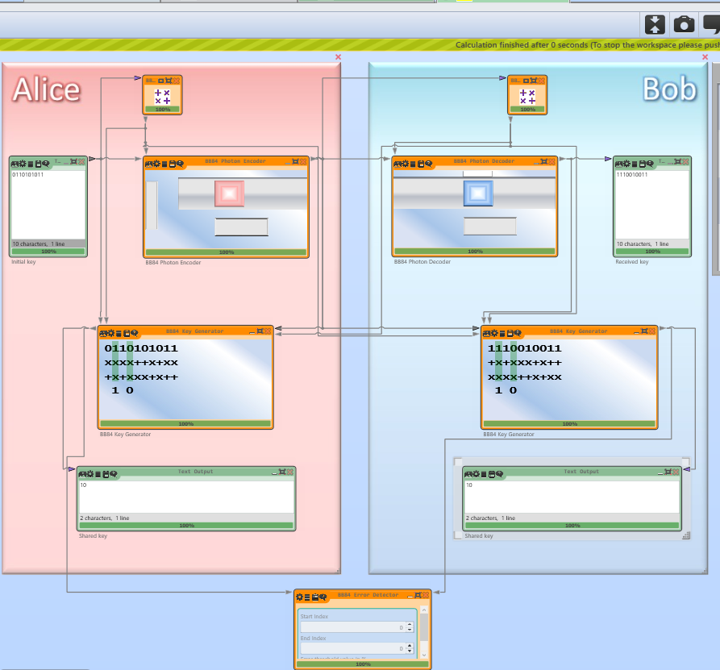

BB84 With Eavesdropping
In this variation, an eavesdropper (Eve) was introduced in the communication channel. Eve attempted to intercept and resend the photons. As BB84 relies on quantum principles, any measurement by Eve disturbs the qubits and introduces errors.
The error detector in CrypTool 2 revealed significantly elevated QBER values. In some cases, the QBER reached 100%, clearly indicating tampering and rendering the key unsafe to use.
Table: BB84 With Eavesdropping
Run | Shared Key | QBER
1 | 101 | 40%
2 | 11110 | 0%
3 | 0 | 100%
4 | 1010 | 0%
5 | 110 | 0%
Screenshot of Simulation (With Eavesdropping) and also the error detector:
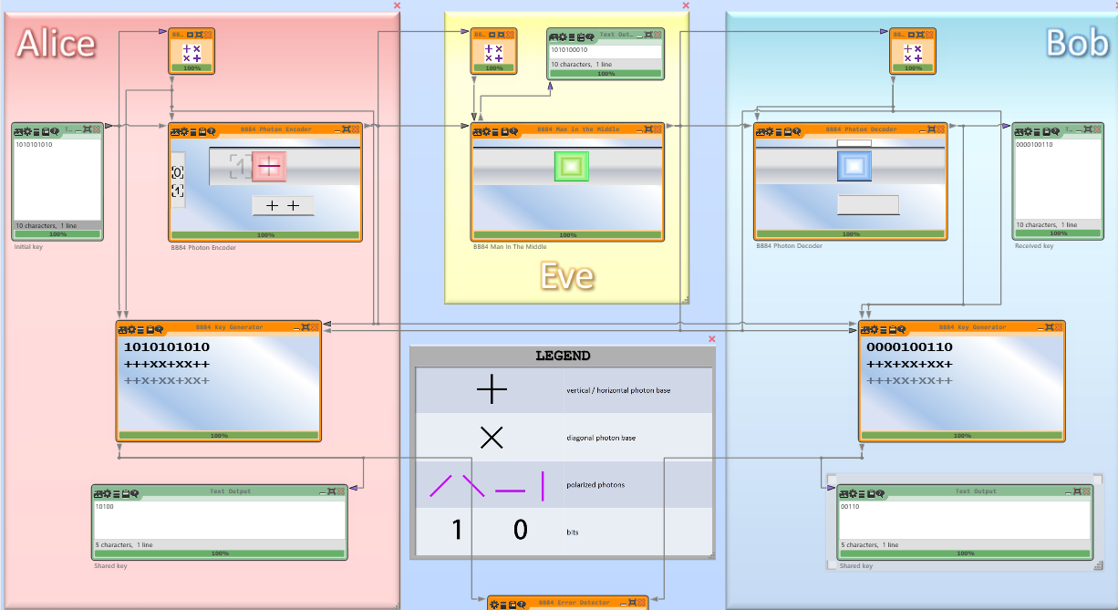
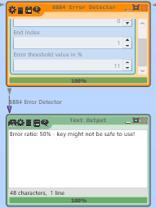

BB84 With Decoy States
The BB84 protocol was extended by introducing decoy states—extra randomly chosen bits inserted during transmission. These bits do not contribute to the final key. Instead, they serve as a check against attacks like Photon Number Splitting (PNS). If an eavesdropper attempts to intercept the qubits, discrepancies in the decoy bits help detect the intrusion.
Since CrypTool 2 does not support decoy states natively, a manual method was used:
- The input key was expanded to 10 bits.
- One decoy position was chosen per run (agreed in advance).
- After CrypTool generated the shared key, the decoy bit was manually removed from both keys.
- The QBER was measured before removing the decoy to assess interference.

Decoy State Without Eavesdropping
This setup involved no eavesdropper. The decoy bit was removed after key generation.
Table: BB84 With Decoy States (No Eavesdropping)
Run | Input Key | Shared Key (Before Sifting) | Decoy Position | Removed Bit | Final Key | QBER
1 | 1011010101 | 1011010 | Index 2 | 1 | 1001010 | 0%
2 | 1111000001 | 11110 | Index 2 | 0 | 1110 | 0%
3 | 1110011110 | 1110011 | Index 3 | 1 | 111001 | 0%
4 | 1001010101 | 10010101 | Index 6 | 0 | 1001011 | 0%
5 | 1010101010 | 10 | Index 3 | - | 10 | 0%

Decoy State With Eavesdropping
Eve was introduced for this run. All five simulations showed a QBER between 50% and 100%, exposing Eve’s presence. The decoy bits were again removed manually after observing QBER.
Table: BB84 With Decoy States (With Eavesdropping)
Run | Input Key | Shared Key (Before Sifting) | Decoy Position | Removed Bit | Final Key | QBER
1 | 1011010101 | 11100 | Index 2 | 1 | 1100 | 50%
2 | 1111000001 | 100010 | Index 2 | 0 | 10010 | 50%
3 | 1110011110 | 01 | Index 3 | - | 01 | 100%
4 | 1001010101 | 00011 | Index 6 | 1 | 00011 | 100%
5 | 1010101010 | 00010 | Index 3 | 0 | 0000 | 50%

Practical Implementation

Hardware Considerations
QKD implementation relies on a blend of quantum and classical components. The source typically generates weak coherent pulses (WCPs) or entangled photons. WCPs are used in BB84-style fibre setups, while entangled sources are crucial for protocols like BBM92 and E91. These photons are transmitted via optical fibre for terrestrial links or via satellite in long-range deployments. Each medium has trade-offs—fibre offers stability but suffers from exponential loss over distance (~0.2 dB/km), while satellite provides longer range but requires precise ground-station synchronisation and atmospheric correction.
Photon detectors are critical to the receiver’s setup. Two main types are:
- Avalanche Photodiodes (APDs): Affordable and widely used but limited in detection efficiency (~10–25%) and prone to dark counts.
- Superconducting Nanowire Single-Photon Detectors (SNSPDs): Far more sensitive (>90% efficiency) and lower noise but require cryogenic cooling and are cost-intensive.
A classical authenticated channel complements the quantum link, allowing Layla and Kamal to perform basis reconciliation, error correction, and privacy amplification without disclosing raw key bits. Any realistic QKD setup is therefore hybrid by nature, with quantum and classical elements tightly integrated.

Deployment Challenges
- Signal Loss: QKD signals degrade over long fibres. Amplifiers cannot be used (they destroy quantum states), making repeaters or trusted nodes necessary.
- Hardware Drift: Misalignment over time affects polarisation accuracy.
- Detector Vulnerabilities: Susceptible to attacks if not properly shielded.
- Operational Costs: Deployment and calibration remain expensive, though costs are gradually decreasing.

Real-World Deployments
- HSBC & Toshiba (UK): A 43 km fibre link was established between Canary Wharf and Southbank. Real-time QKD was used to secure trading data, monitored by automated QBER dashboards (Dynes et al., 2019).
- ID Quantique (South Korea): Deployed in national telecom infrastructure, including integration with 5G backhaul networks to secure real-time data streams (ID Quantique, 2023).
- Tokyo QKD Network (Japan): Multi-vendor network securing Tokyo Stock Exchange transactions with QKD over metropolitan fibre routes (Sasaki et al., 2011).
- China’s Beijing–Shanghai Backbone: Over 2,000 km of fibre using trusted nodes. Supported military, financial, and diplomatic communication (Chen et al., 2021).
- EuroQCI (EU): A €1 billion initiative aiming to launch satellite-based QKD and build an EU-wide secure quantum network by 2027 (European Commission, 2023).
These deployments highlight how QKD is shifting from theoretical to operational. Institutions that participate early not only improve security posture but influence future standards, vendor ecosystems, and regulatory direction.

Vulnerabilities and Mitigations
Attack Type | Description | Mitigation
Photon-Number Splitting | Exploits multi-photon emissions in BB84 | Decoy-State BB84
Detector Blinding | Sends strong light pulses to blind detectors | Monitoring input power, MDI-QKD
Trojan Horse | Injects light to extract internal settings | Optical isolators, filters
Side-Channel Leakage | Leaks via power fluctuations, timing, or acoustic signals | Shielding, hardware audits
Man-in-the-Middle (MITM) | Rhea impersonates Layla or Kamal on classical channel | Digital signatures, authentication
A famous real-world attack in 2010 (Lydersen et al., 2010) demonstrated how commercial detectors could be blinded using bright light, allowing key interception without increasing QBER. This attack shook the community and accelerated research into Measurement-Device Independent QKD, where detectors are placed in an untrusted third party.

Recommendations for Financial Institutions
Adopt Decoy-State BB84 for Fibre Links — Especially for inter-office communications in major cities.
Pilot MDI-QKD Systems — For high-value data streams such as trading and compliance.
Use Hybrid Encryption — Combine QKD for key exchange with post-quantum algorithms like CRYSTALS-Kyber (NIST, 2023).
Integrate QBER Monitoring Tools — Automate alerts for anomalous error rates.
Plan for Satellite QKD — Establish strategic partnerships for global secure links.
Training & Compliance — Educate IT/security teams on QKD deployment, limitations, and contingency planning.

Going Further: Scaling QKD for the Future
Quantum Key Distribution is maturing rapidly, but achieving global-scale deployment requires overcoming technological and logistical hurdles. One of the most pressing limitations is distance. Fibre-based QKD suffers exponential loss over long spans, restricting practical use to urban or inter-city networks. To address this, quantum repeaters are being developed, which can extend QKD range without requiring trusted relay nodes (Briegel et al., 1998). While not yet commercially viable, experimental repeaters using quantum memories and entanglement swapping are making progress.
Another innovation is Measurement Device-Independent QKD (MDI-QKD). In MDI-QKD, both parties send photons to an untrusted third-party node that performs a Bell-state measurement. Because neither party directly receives the photons, vulnerabilities like detector blinding are eliminated (Lo, Curty and Qi, 2012). This shifts the security model and paves the way for future QKD networks in hostile or compromised environments.
The integration of QKD with classical infrastructure is also evolving. Companies are now exploring how to embed QKD into software-defined networks (SD-WANs) or 5G backbones. Meanwhile, the European Union's EuroQCI programme is preparing for satellite-based QKD launches by 2027 (European Commission, 2023). Japan’s Tokyo QKD Network and China’s Beijing-Shanghai QKD backbone further illustrate national-level adoption.
Financial institutions that invest early will be positioned not just for quantum resilience, but for compliance with emerging standards by NIST, ETSI, and the ITU. As QKD hardware becomes more affordable and scalable, hybrid solutions combining QKD with post-quantum algorithms will define the gold standard for secure communication.

Financial Impact and ROI Consideration
While QKD promises unbreakable encryption, financial institutions must consider cost, scalability, and compliance benefits. The cost of deploying fibre-based QKD currently ranges between £20,000 to £50,000 per kilometre depending on equipment and integration complexity. However, this is offset by the long-term value: eliminating key distribution vulnerabilities, reducing breach risk, and staying ahead of compliance mandates.
Regulators such as the European Central Bank and the Bank of England are already evaluating quantum-resilient infrastructures. For a multinational bank, securing intercontinental branches via QKD could prevent financial and reputational loss from state-sponsored quantum attacks.
Moreover, institutions that pioneer QKD adoption may benefit from government subsidies or future regulatory advantages. Quantum-resilient firms will likely outperform competitors once quantum-readiness becomes an industry benchmark.

Conclusion
QKD offers provable, physics-based security for key distribution—something no classical system can guarantee in a quantum future. Simulation results confirm that eavesdropping introduces significant errors, which can be detected and mitigated.
Financial institutions, as high-value targets for cyber espionage, cannot afford to delay. Strategic deployment of QKD, supported by hybrid encryption and layered security policies, is no longer an academic exercise—it’s a necessity. With declining costs and increasing government support, early adopters will enjoy not just enhanced security but regulatory and reputational advantage.

References
Bennett, C.H. and Brassard, G. (1984). Quantum cryptography: Public key distribution and coin tossing. Proceedings of IEEE International Conference on Computers, Systems and Signal Processing, pp.175–179.
Bennett, C.H., Brassard, G. and Mermin, N.D. (1992). Quantum cryptography without Bell’s theorem. Physical Review Letters, 68(5), pp.557–559.
Briegel, H.J., Dür, W., Cirac, J.I. and Zoller, P. (1998). Quantum repeaters: The role of imperfect local operations in quantum communication. Physical Review Letters, 81(26), pp.5932–5935.
Chen, Y.-A. et al. (2021). An integrated space-to-ground quantum communication network over 4,600 kilometres. Nature, 589(7841), pp.214–219.
Dynes, J.F. et al. (2019). Cambridge quantum secure network trial. Quantum Science and Technology, 4(4), p.045009.
Ekert, A.K. (1991). Quantum cryptography based on Bell’s theorem. Physical Review Letters, 67(6), pp.661–663.
European Commission (2023). European Quantum Communication Infrastructure (EuroQCI). [online] Available at: https://digital-strategy.ec.europa.eu/en/policies/euroqci [Accessed 25 Mar. 2025].
ID Quantique (2023). Quantum-safe solutions for 5G networks. [online] Available at: https://www.idquantique.com [Accessed 25 Mar. 2025].
Lo, H.K., Ma, X. and Chen, K. (2005). Decoy state quantum key distribution. Physical Review Letters, 94(23), p.230504.
Lo, H.K., Curty, M. and Qi, B. (2012). Measurement-device-independent quantum key distribution. Physical Review Letters, 108(13), p.130503.
Lydersen, L. et al. (2010). Hacking commercial quantum cryptography systems by tailored bright illumination. Nature Photonics, 4(10), pp.686–689.
Mosca, M. (2018). Cybersecurity in an era with quantum computers: Will we be ready? IEEE Security & Privacy, 16(5), pp.38–41.
NIST (2023). Post-Quantum Cryptography Standardization. [online] Available at: https://csrc.nist.gov/projects/post-quantum-cryptography
Sasaki, M. et al. (2011). Field test of quantum key distribution in the Tokyo QKD Network. Optics Express, 19(11), pp.10387–10409.
Yin, J. et al. (2017). Satellite-based entanglement distribution over 1200 kilometers. Science, 356(6343), pp.1140–1144.

